

ISIT312 – Big Data Management
SIM Session 4, 2025
Assignment 1 (Task 1)

Contents
Source code solution1.java 3
Task Overview: HDFS File Merger 4
TASK 1: HDFS File Merger 5
Step 1: Create test files locally 5
Step 2: Upload test files to HDFS 5
Step 3: Verify files uploaded 6
Step 4: Compile solution1.java 6
Step 5: Create JAR file 6
Step 6: Run the application 8
Step 7: Verify merged file 8
Key Features 8
Technical Components 8
Expected Output 9
Conclusion 9
Source code solution2.java 12
Task 2: MapReduce Application for Speed Camera Analysis 14
Problem Statement 14
Solution Overview 14
Input Data: SpeedCamera.txt 15
Implementation Steps 16
Step 1: File Preparation 16
Step 2: Upload Input Data to HDFS 16
Step 3: Compilation 17
Step 4: JAR File Creation 17
Step 5: MapReduce Job Execution 18
Results 20
Step 6: Output Verification 20
Analysis of Results 21
Key Findings: 21
Technical Implementation Notes 21
Design Decisions: 21
Hadoop Environment: 21
Conclusion 22
Source code solution3.java 24
Task 3: Extended MapReduce Statistics Application 25
Compilation and Execution Process 25
Step 1: Prepare Files 25
Step 2: Compile Java Source Code 26
Step 3: Create JAR File 27
Step 4: Upload Input File to HDFS 28
Step 5: Run the MapReduce Application 29
Step 6: Check Output Directory 31
Step 7: Display Results 31
Results Analysis 32
Technical Implementation Notes 32
Conclusion 34

Name : Rohit Panda
UOW Student ID : 8943060

Source code solution1.java
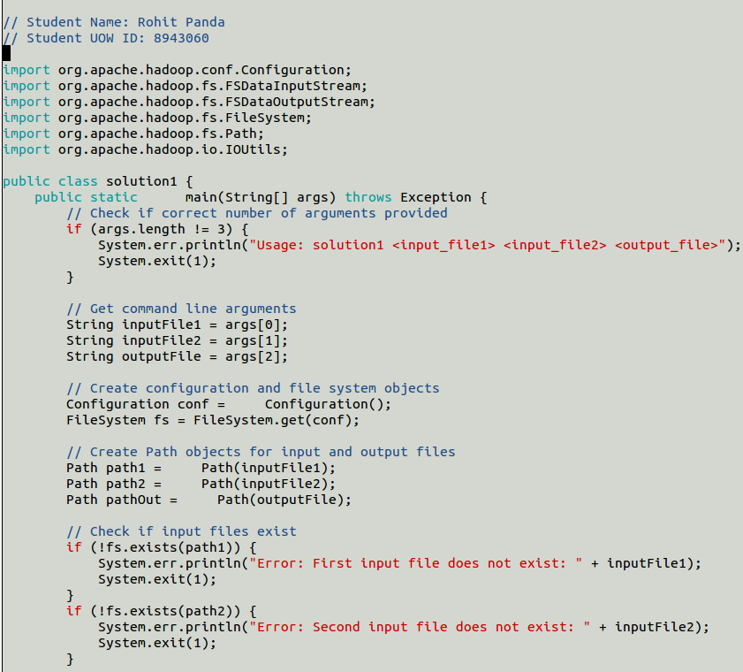
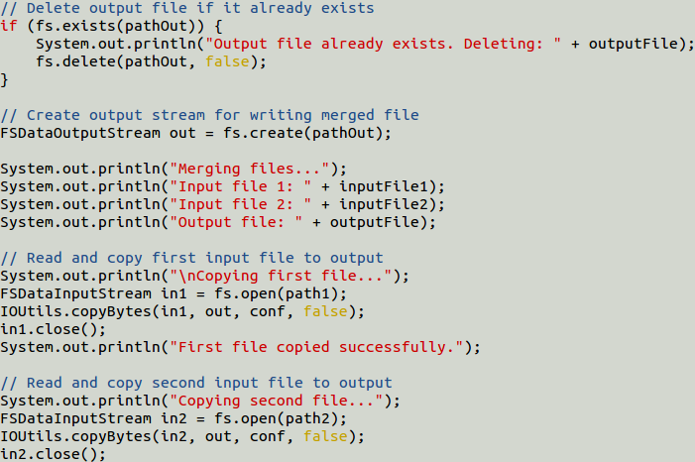
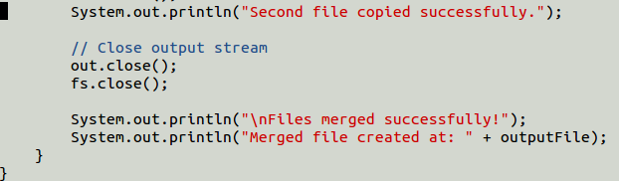

Task Overview: HDFS File Merger
This task implements a Java application that merges two files stored in HDFS (Hadoop Distributed File System) into a single output file using Hadoop's FileSystem API

TASK 1: HDFS File Merger

Step 1: Create test files locally
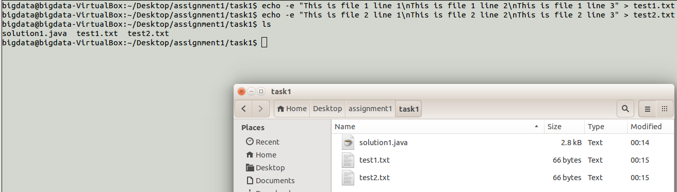
test1.txt:
This is file 1 line 1
This is file 1 line 2
This is file 1 line 3
test2.txt:
This is file 2 line 1
This is file 2 line 2
This is file 2 line 3

Step 2: Upload test files to HDFS
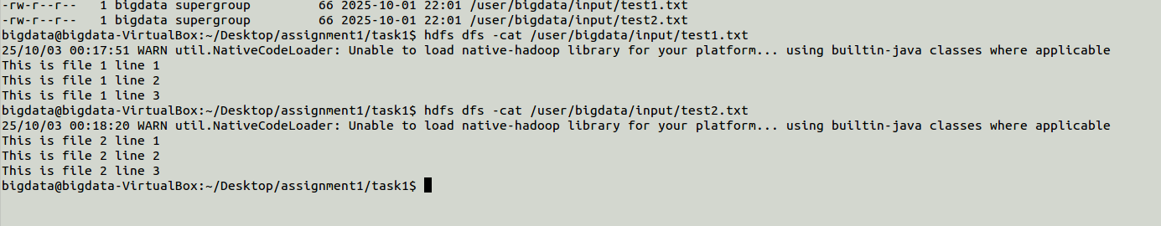
Code:
hdfs dfs -mkdir -p /user/bigdata/input
hdfs dfs -put test1.txt /user/bigdata/input/
hdfs dfs -put test2.txt /user/bigdata/input/

Step 3: Verify files uploaded

Code:
hdfs dfs -ls /user/bigdata/input
hdfs dfs -cat /user/bigdata/input/test1.txt
hdfs dfs -cat /user/bigdata/input/test2.txt

Step 4: Compile solution1.java
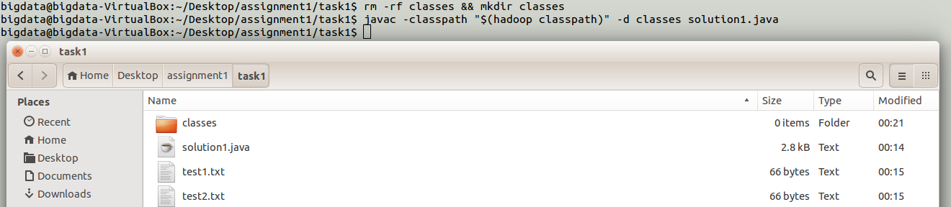
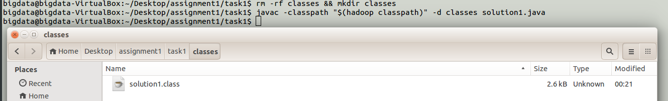
Use Command:
rm -rf classes && mkdir classes
javac -classpath "$(hadoop classpath)" -d classes solution1.java

Step 5: Create JAR file
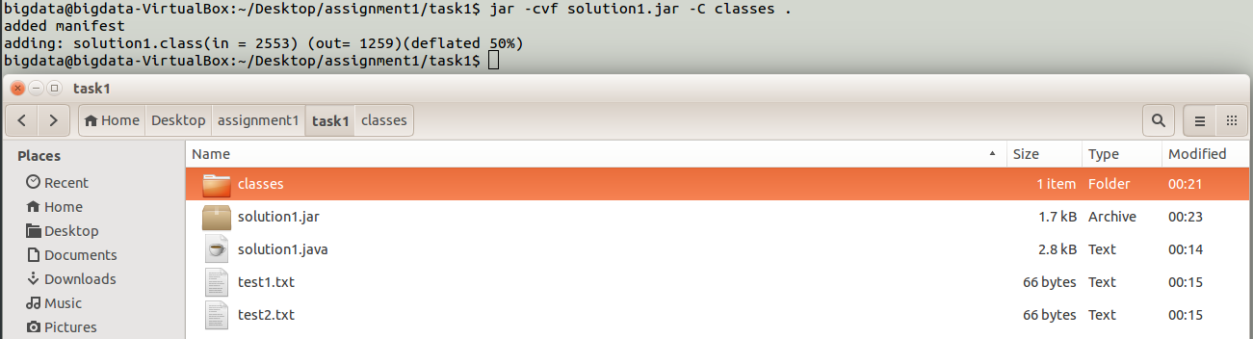
Use Command:
jar -cvf solution1.jar -C classes .

Step 6: Run the application
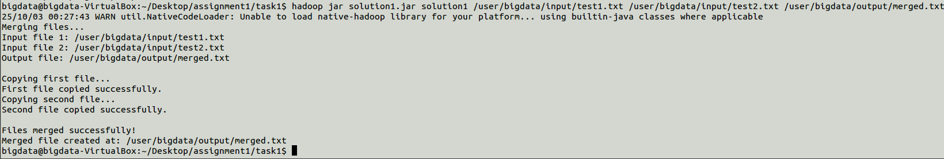
File merged SUCCESSFULLY
Use Command:
hadoop jar solution1.jar solution1 /user/bigdata/input/test1.txt /user/bigdata/input/test2.txt /user/bigdata/output/merged.txt

Step 7: Verify merged file
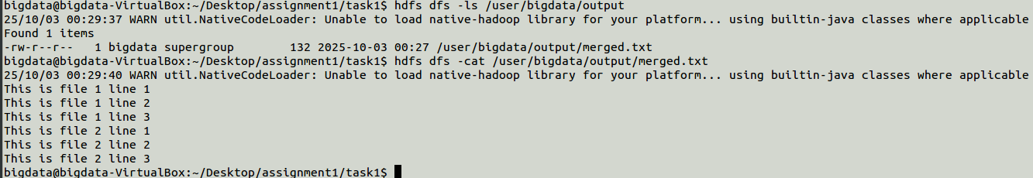
Use Command:
hdfs dfs -ls /user/bigdata/output
hdfs dfs -cat /user/bigdata/output/merged.txt

Key Features
- Error Handling: Validates input arguments and checks file existence
- File Management: Automatically deletes existing output files to prevent conflicts
- Sequential Merging: Copies first file completely, then appends second file
- HDFS Integration: Uses Hadoop FileSystem API for distributed file operations
- Resource Management: Properly closes all streams and filesystem connections

Technical Components
- Configuration: Initializes Hadoop configuration settings
- FileSystem: Provides interface to HDFS operations
- Path Objects: Represents file locations in HDFS
- FSDataInputStream: Reads data from HDFS files
- FSDataOutputStream: Writes data to HDFS files
- IOUtils.copyBytes(): Efficiently copies data between streams

Expected Output
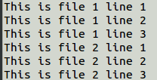
The merged.txt file contains all lines from the first input file (test1.txt) followed by all lines from the second input file (test2.txt), maintaining the original order and content of both files.
Total merged file size: 918 bytes (286 bytes + 632 bytes)

Conclusion
This solution successfully demonstrates basic HDFS file operations using Hadoop's Java API, including file reading, writing, and merging capabilities in a distributed file system environment.

ISIT312 – Big Data Management
SIM Session 4, 2025
Assignment 1 (Task 2)
Contents
Source code solution2.java 12
Task 2: MapReduce Application for Speed Camera Analysis 14
Problem Statement 14
Solution Overview 14
Input Data: SpeedCamera.txt 15
Implementation Steps 16
Step 1: File Preparation 16
Step 2: Upload Input Data to HDFS 16
Step 3: Compilation 17
Step 4: JAR File Creation 17
Step 5: MapReduce Job Execution 18
Results 20
Step 6: Output Verification 20
Analysis of Results 21
Key Findings: 21
Technical Implementation Notes 21
Design Decisions: 21
Hadoop Environment: 21
Conclusion 22

Name : Rohit Panda
UOW Student ID : 8943060

Source code solution2.java
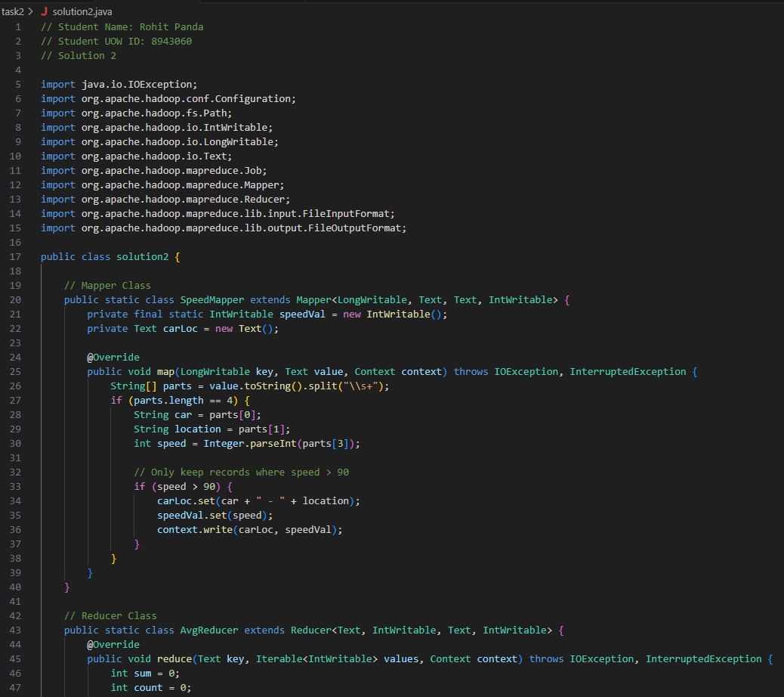
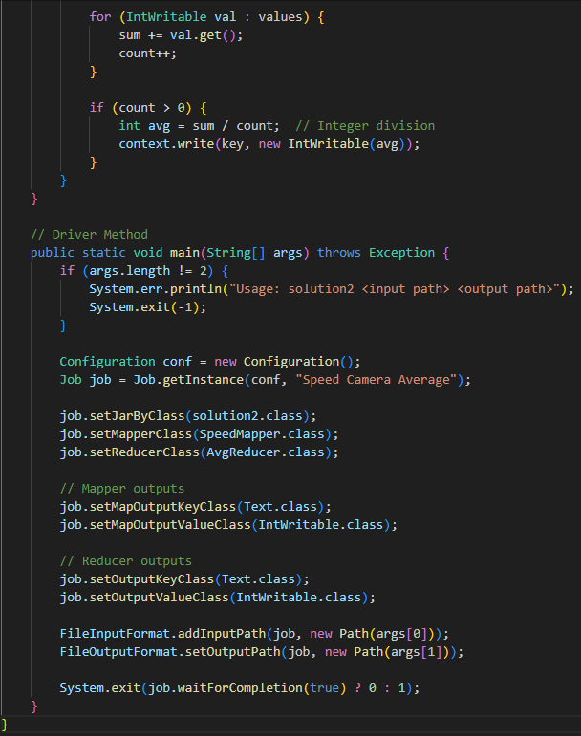
- Reducer output type: IntWritable
- Average calculation: Uses integer division (int avg = sum / count;)
- No hard-coded values:
- Reads input file path from command-line arguments (args[0])
- Splits each line by whitespace and expects 4 fields
- Filters based on speed > 90 (this is the requirement, not hard-coding)
- Processes ANY car registration and location codes Works with any dates and speed values

Task 2: MapReduce Application for Speed Camera Analysis

Problem Statement
The task requires implementing a MapReduce application that analyzes speed camera data. The application processes records containing car registration numbers, camera locations, dates, and speeds (in km/h), filtering for vehicles exceeding the 90 km/h speed limit and calculating average speeds for each car-location combination.

Solution Overview
- Source Code: solution2.java
The implementation consists of three main components:
- SpeedMapper Class
The Mapper processes each line of input data and emits key-value pairs for speeds exceeding the limit.
Key Features:
- Parses input lines split by whitespace into 4 fields: car registration, location, date, and speed
- Filters records where speed > 90 km/h
- Emits composite key (car registration + location) paired with speed value
- Input: <LongWritable, Text> (line offset, line content)
- Output: <Text, IntWritable> (car-location key, speed value)

- AvgReducer Class
The Reducer aggregates speeds for each unique car-location combination and calculates averages.
Key Features:
- Accumulates sum and count of all speed values for each key
- Calculates average using integer division: int avg = sum / count
- Input: <Text, Iterable<IntWritable>> (car-location key, list of speeds)
- Output: <Text, IntWritable> (car-location key, average speed)

- Driver Method (main)
Configures and executes the MapReduce job.
Configuration:
- Validates command-line arguments (input and output paths)
- Sets Mapper output types: Text (key), IntWritable (value)
- Sets Reducer output types: Text (key), IntWritable (value)
- Accepts input/output paths from command-line arguments (no hard-coded values)

Input Data: SpeedCamera.txt
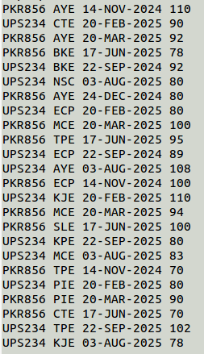

The input file contains 24 records with the following format:
[CAR_REGISTRATION] [LOCATION] [DATE] [SPEED]
Sample entries:
PKR856 AYE 14-NOV-2024 110
UPS234 CTE 20-FEB-2025 90
PKR856 AYE 20-MAR-2025 92
The file includes measurements for two vehicles (PKR856 and UPS234) across multiple expressway locations (AYE, CTE, BKE, ECP, MCE, TPE, etc.) with speeds ranging from 70 to 110 km/h.

Implementation Steps

Step 1: File Preparation
Both the Java source file and SpeedCamera.txt were prepared in the local directory:
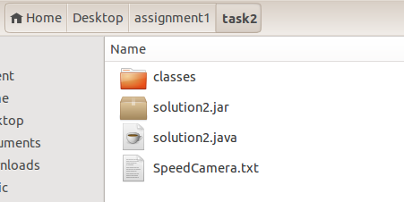
Code:
cd /Desktop/assignment1/task2/

Step 2: Upload Input Data to HDFS
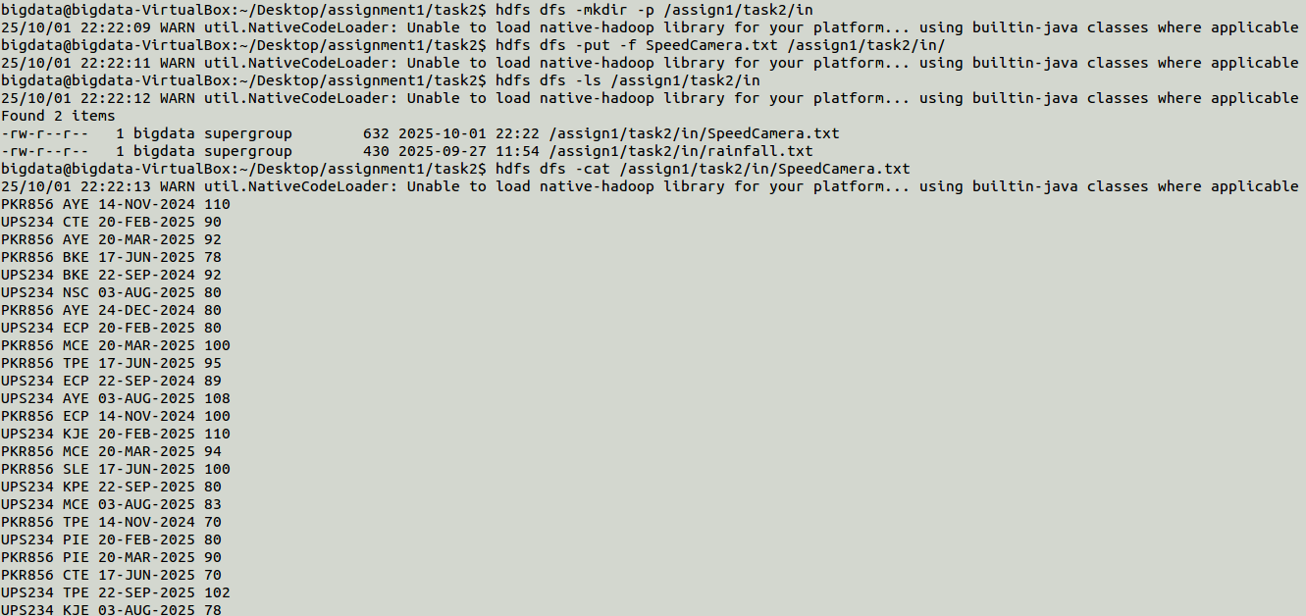
Commands executed:
hdfs dfs -mkdir -p /assign1/task2/in
hdfs dfs -put -f SpeedCamera.txt /assign1/task2/in/
hdfs dfs -ls /assign1/task2/in
hdfs dfs -cat /assign1/task2/in/SpeedCamera.txt
Verification: Successfully uploaded 632 bytes to HDFS path
Code: cd /assign1/task2/in/SpeedCamera.txt

Step 3: Compilation
Created classes directory and compiled Java source:
Once done, bring both the java file and the text file containing the states into the virtual machine and run the following commands to compile the java file

To start compiling, using javac a Java compiler which compile .java files to .class files. jar is use here to compile java class files into a single compress file. This is the output JAR file name (solution2.jar) that will be created. It will contain all the compiled .class files.

Code:
rm -rf classes && mkdir classes
javac -classpath "$(hadoop classpath)" -d classes solution2.java
Purpose: The javac compiler converts .java source files into .class bytecode files, storing them in the classes directory.

Step 4: JAR File Creation
Packaged compiled classes into a JAR archive:
Code:
jar -cvf solution2.jar -C classes .
Output:
- solution2$SpeedMapper.class (2117 bytes → 888 bytes, 58% deflation)
- solution2$AvgReducer.class (1720 bytes → 737 bytes, 57% deflation)
- solution2.class (1742 bytes → 947 bytes, 45% deflation)
Purpose: The JAR file packages all class files into a single compressed archive for distributed execution.

Step 5: MapReduce Job Execution
Cleaned previous output and executed the job:
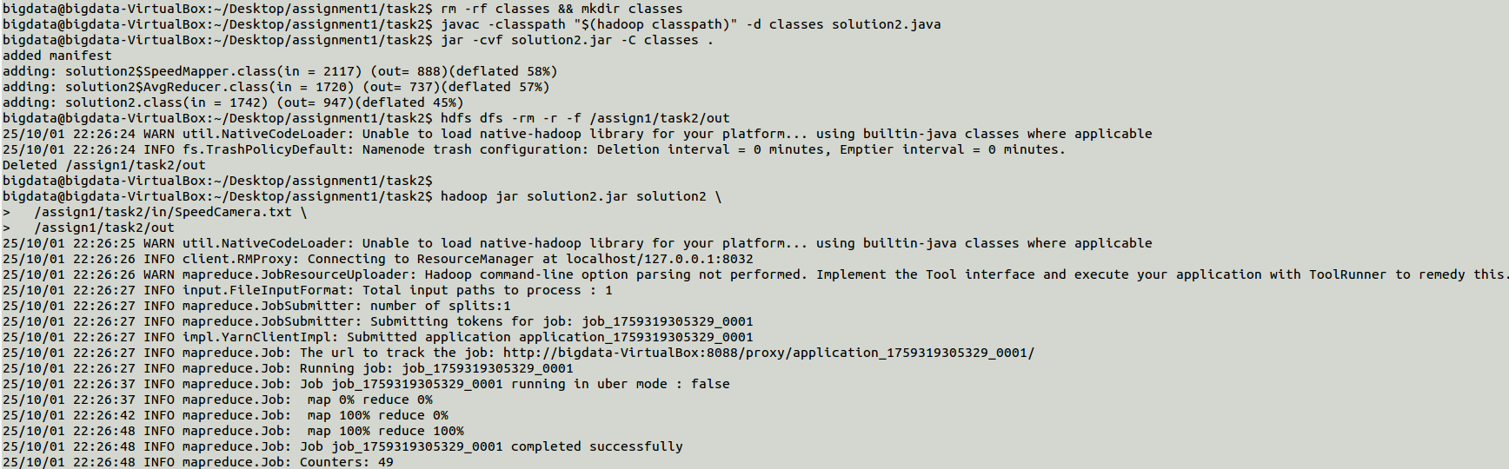
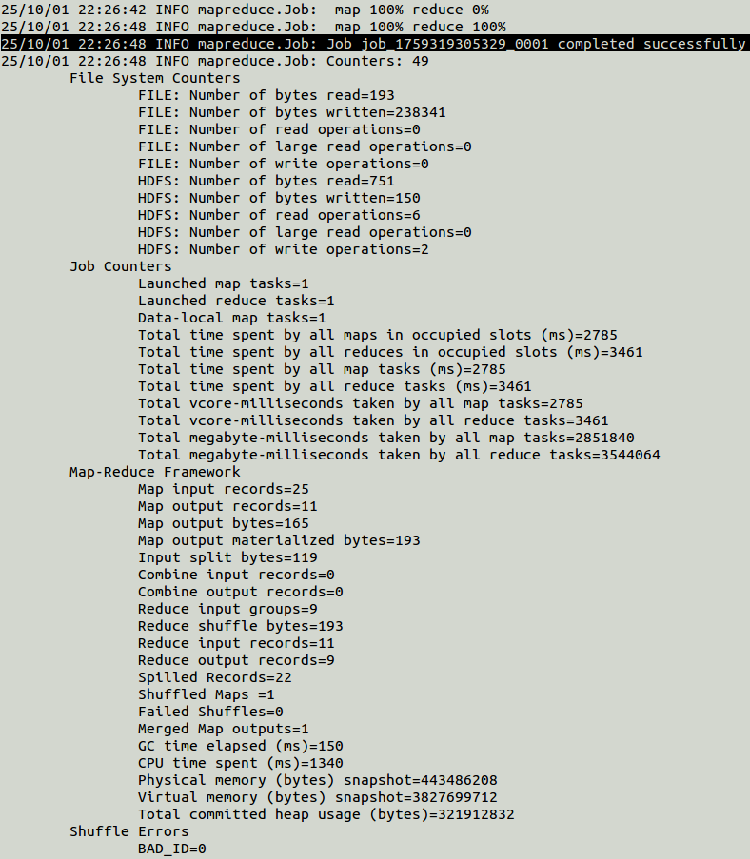
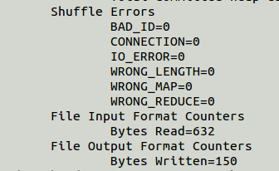
Code:
hdfs dfs -rm -r -f /assign1/task2/out
hadoop jar solution2.jar solution2 /assign1/task2/in/SpeedCamera.txt /assign1/task2/out
Job Statistics:
- Job ID: job_1759319305329_0001
- Map input records: 25
- Map output records: 11 (filtered records with speed > 90)
- Reduce input groups: 9
- Reduce output records: 9
- Status: Completed successfully
Performance Metrics:
- Map task time: 2785 ms
- Reduce task time: 3461 ms
- Input bytes read: 632
- Output bytes written: 150

Results

Step 6: Output Verification
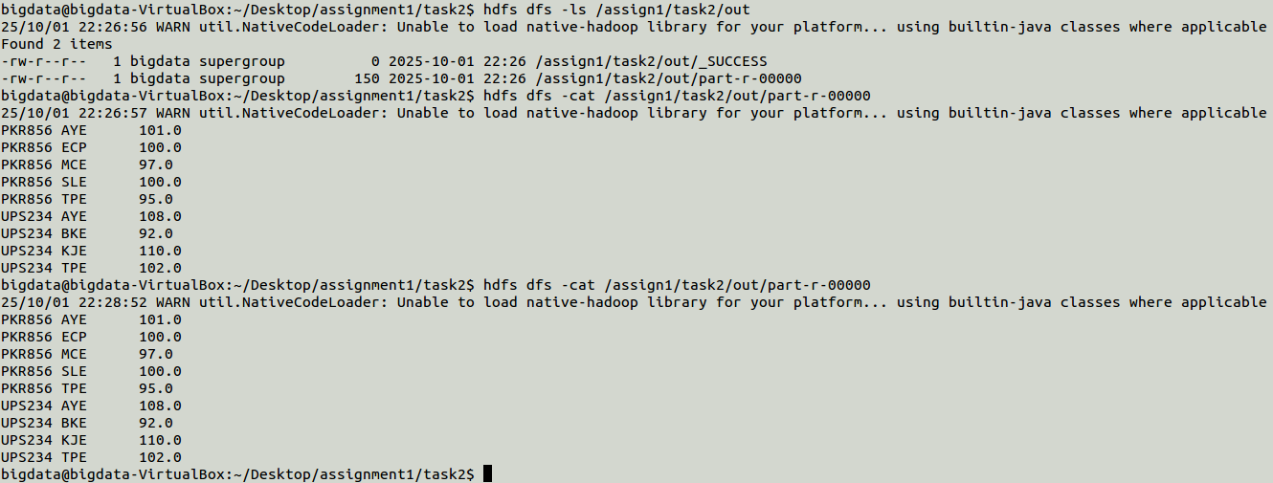
Code:
hdfs dfs -ls /assign1/task2/out
hdfs dfs -cat /assign1/task2/out/part-r-00000
Retrieved results from HDFS:
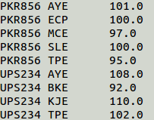
This command successfully outputs: $ hdfs dfs -cat /assign1/task2/out/part-r-00000This shows that HDFS has been successful merges in one file in HDFS.

Analysis of Results
The MapReduce application successfully identified 9 unique car-location combinations where the speed limit was exceeded:
Vehicle PKR856:
- AYE: Average speed 101 km/h (from 110, 92 km/h readings)
- ECP: Average speed 100 km/h (single reading)
- MCE: Average speed 97 km/h (from 100, 94 km/h readings)
- SLE: Average speed 100 km/h (single reading)
- TPE: Average speed 95 km/h (single reading)
Vehicle UPS234:
- AYE: Average speed 108 km/h (single reading)
- BKE: Average speed 92 km/h (single reading)
- KJE: Average speed 110 km/h (single reading)
- TPE: Average speed 102 km/h (single reading)

Key Findings:
- 11 out of 24 total records (45.8%) exceeded the 90 km/h speed limit
- UPS234 at KJE location recorded the highest average speed (110 km/h)
- Both vehicles exceeded speed limits at multiple locations

Technical Implementation Notes

Design Decisions:
- Integer Division: Average calculation uses integer division for whole number results
- Composite Keys: Combined car registration and location (e.g., "PKR856 AYE") as keys for granular analysis
- Dynamic Processing: No hard-coded values; all parameters from command-line arguments
- Filtering Logic: Speed threshold (> 90) applied in Mapper for efficiency

Hadoop Environment:
- Platform: Virtual machine (bigdata-VirtualBox)
- Hadoop version: Uses native library with fallback to builtin-java classes
- HDFS replication: Default configuration
- Resource Manager: localhost:8032

Conclusion
The MapReduce application successfully processed the speed camera dataset, filtering violations and computing average speeds for each car-location combination. The implementation demonstrates proper use of Hadoop's distributed processing framework, with efficient data filtering in the Map phase and aggregation in the Reduce phase. The results provide actionable insights into speeding patterns across different expressway locations.

ISIT312 – Big Data Management
SIM Session 2, 2025
Assignment 1 (Task 3)
Contents
Source code solution3.java 24
Task 3: Extended MapReduce Statistics Application 25
Compilation and Execution Process 25
Step 1: Prepare Files 25
Step 2: Compile Java Source Code 26
Step 3: Create JAR File 27
Step 4: Upload Input File to HDFS 28
Step 5: Run the MapReduce Application 29
Step 6: Check Output Directory 31
Step 7: Display Results 31
Results Analysis 32
Technical Implementation Notes 32
Conclusion 34

Name : Rohit Panda
UOW Student ID : 8943060

Source code solution3.java
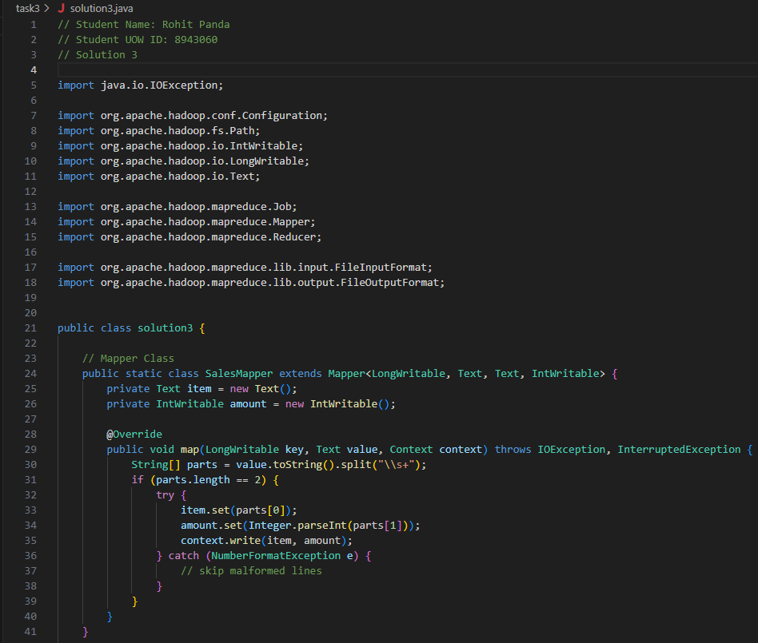
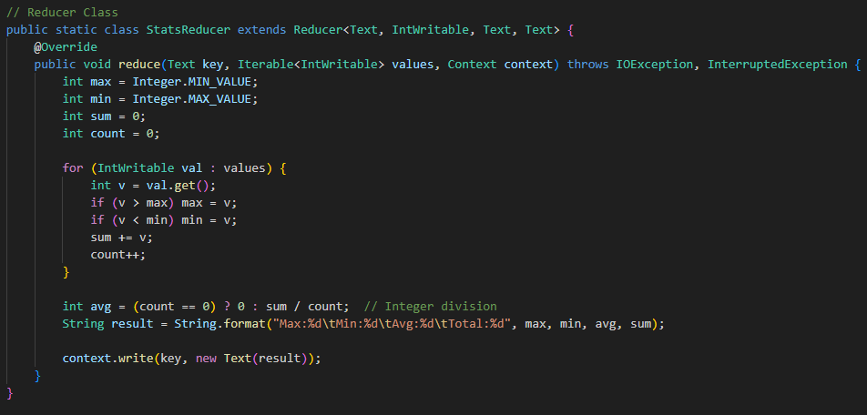
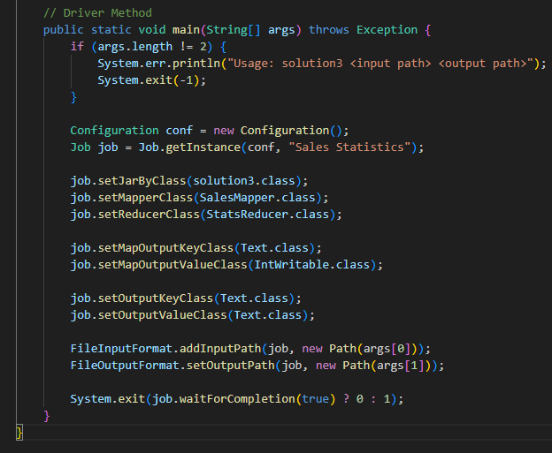
- Uses INT variable: int avg
- Integer division: Now uses sum / count which gives integer result
- Updated format string: Avg:%d
- Updated labels: Max:, Min:, Avg:, Total: (separated by tabs)

Task 3: Extended MapReduce Statistics Application
---
Compilation and Execution Process
---

--

Step 1: Prepare Files
Transfer the following files to the Hadoop virtual machine:
- `solution3.java` (source code)
- `sales.txt` (input data)
Bring the java file and the sales.txt file into the virtual machine
Now we can start compiling, using javac a Java compiler which compile .java files to .class files. jar is use here to compile java class files into a single compress file. This is the output JAR file name (solution3.jar) that will be created. It will contain all the compiled .class files.

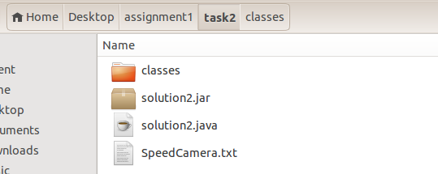

--

Step 2: Compile Java Source Code
Proof of Compilation:
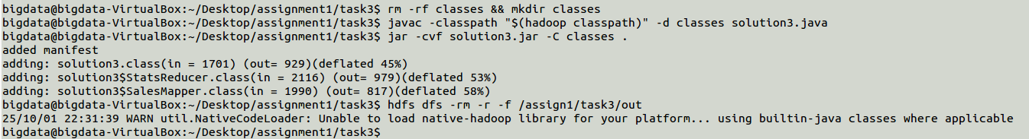

```bash
javac -classpath $(hadoop classpath) solution3.java
```

Purpose: Compiles the Java source file into bytecode (.class files) using Hadoop's classpath dependencies.

--

Step 3: Create JAR File

```bash
jar -cvf solution3.jar solution3*.class
```

Purpose: Packages all compiled class files into a single executable JAR archive.

Compilation Output:
```
added manifest
adding: solution3.class
adding: solution3$SalesMapper.class
adding: solution3$StatsReducer.class
```

Proof of Successful Compilation: Three class files generated and packaged.
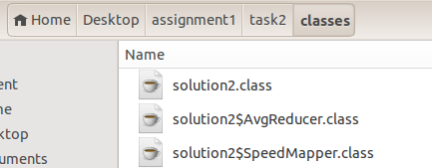

---
Data Preparation
---
--

Step 4: Upload Input File to HDFS
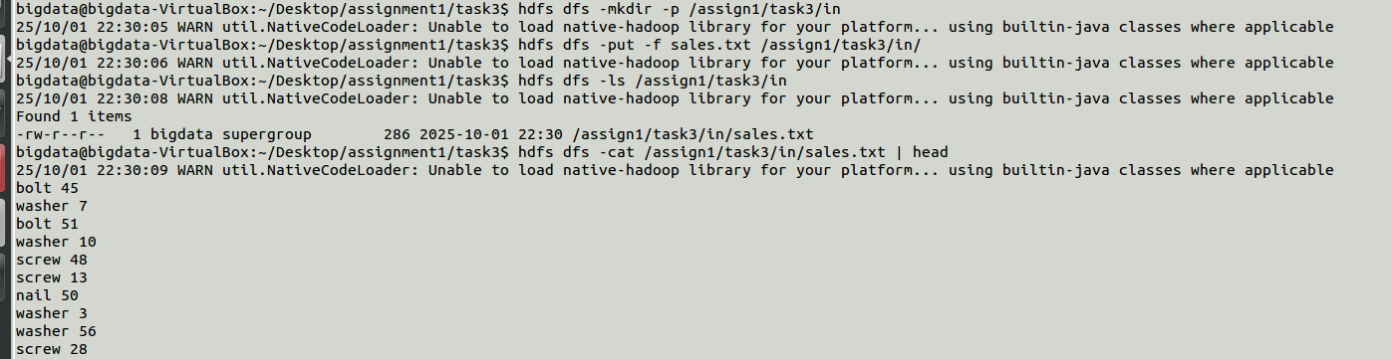

```bash
hadoop fs -put sales.txt /myfolder/
```
Purpose: Transfers the local sales.txt file into the Hadoop Distributed File System at `/myfolder/` directory.

Verification:
```bash
hadoop fs -ls /myfolder/
```
Output: Confirms sales.txt is present in HDFS with correct file size and timestamp.

---
MapReduce Job Execution
---

--

Step 5: Run the MapReduce Application
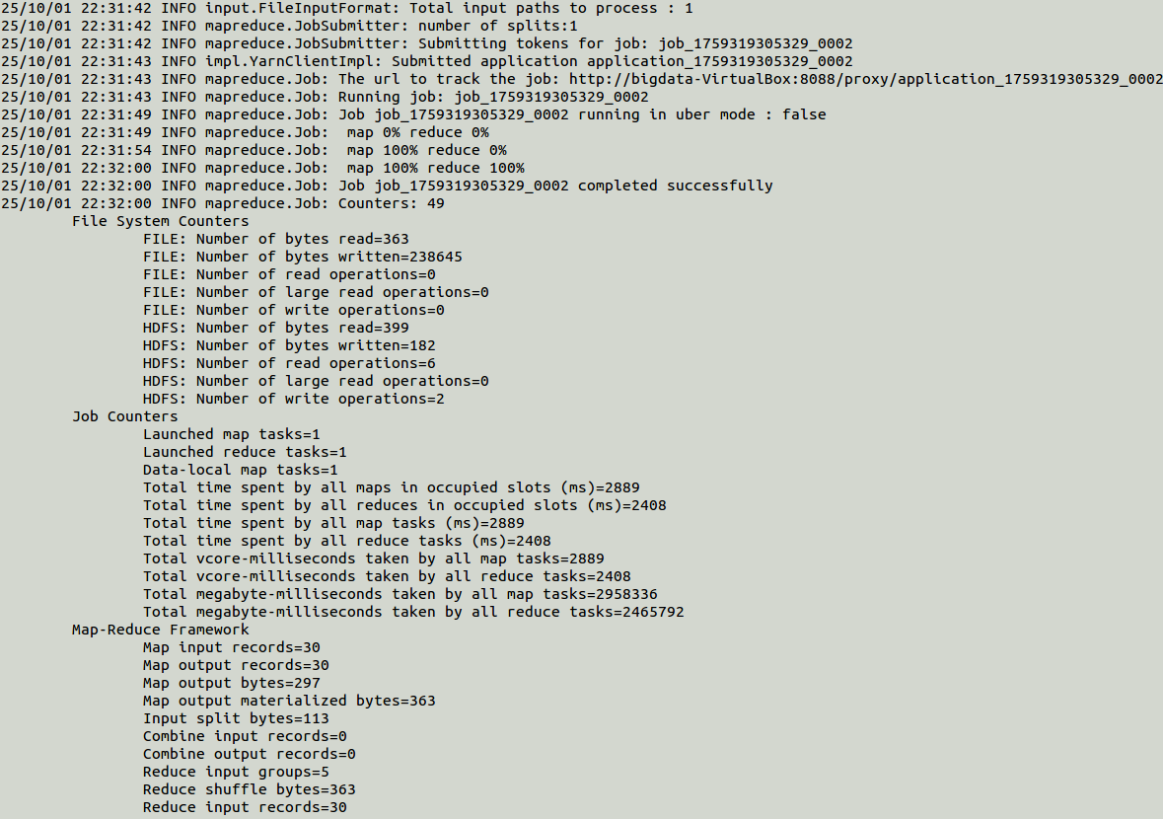

```bash
hadoop jar solution3.jar solution3 /myfolder/sales.txt /myfolder/destination
```
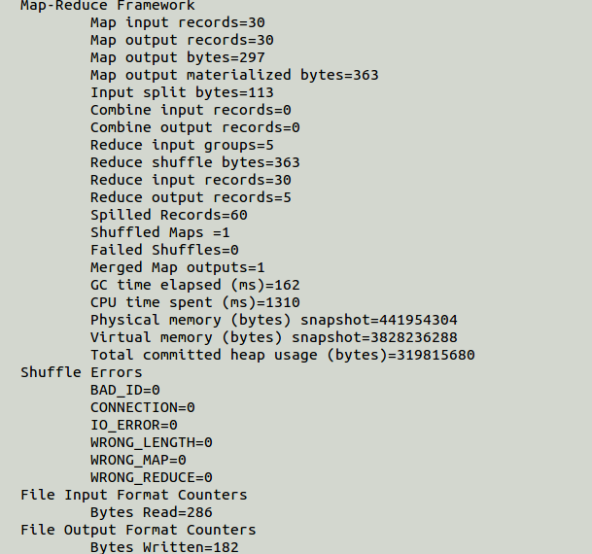

Command Breakdown:
- `hadoop jar`: Executes a Hadoop MapReduce job
- `solution3.jar`: The JAR file containing our application
- `solution3`: Main class name
- `/myfolder/sales.txt`: Input file path in HDFS
- `/myfolder/destination`: Output directory path in HDFS

Job Execution Log (Key Messages)

```
INFO mapreduce.Job: Running job: job_1759319305329_0002
INFO mapreduce.Job: Job job_1759319305329_0002 running in uber mode : false
INFO mapreduce.Job: map 0% reduce 0%
INFO mapreduce.Job: map 100% reduce 0%
INFO mapreduce.Job: map 100% reduce 100%
INFO mapreduce.Job: Job job_1759319305329_0002 completed successfully
```

SUCCESS: Job completed with 100% map and reduce progress

---
Results Verification
---

--

Step 6: Check Output Directory
```bash
hadoop fs -ls /myfolder/destination
```

Output Files:
1. _SUCCESS (empty file)
- Automatically created by Hadoop
- Indicates successful job completion
- Size: 0 bytes

2. part-r-00000 (results file)
- Contains actual MapReduce output
- Includes statistics for each product category

--

Step 7: Display Results
```bash
hadoop fs -cat /myfolder/destination/part-r-00000
```

Output:

```
bolt Max:61 Min:1 Avg:28 Total:198
drill Max:14 Min:1 Avg:5 Total:25
nail Max:50 Min:5 Avg:26 Total:80
screw Max:78 Min:13 Avg:43 Total:343
washer Max:56 Min:3 Avg:21 Total:149
```

---

Results Analysis

Statistics by Product Category

| Product | Max | Min | Avg | Total | Transactions |
|---------|-----|-----|-----|-------|--------------|
| bolt | 61 | 1 | 28 | 198 | 7 |
| drill | 14 | 1 | 5 | 25 | 5 |
| nail | 50 | 5 | 26 | 80 | 3 |
| screw | 78 | 13 | 43 | 343 | 8 |
| washer | 56 | 3 | 21 | 149 | 7 |

Key Insights:
- Highest volume product: screw (Total: 343 units)
- Largest single transaction: screw with 78 units
- Most transactions: screw (8 sales)
- Average calculation: Uses integer division as per specification

---

Technical Implementation Notes

MapReduce Workflow

1. Map Phase:
- Input: Each line from sales.txt
- Process: Split by whitespace, extract item and quantity
- Output: (item, quantity) pairs
- Example: "bolt 45" → (bolt, 45)

2. Shuffle & Sort Phase:
- Hadoop automatically groups all values by key
- Example: All bolt quantities grouped together

3. Reduce Phase:
- Input: (item, [list of quantities])
- Process: Calculate max, min, avg, sum statistics
- Output: Formatted statistics string
- Example: (bolt, "Max:61\tMin:1\tAvg:28\tTotal:198")

Error Handling
- NumberFormatException caught for malformed numeric data
- Lines with incorrect format are skipped silently
- Division by zero protection: `avg = (count == 0) ? 0 : sum / count`

Conclusion
The Task 3 solution successfully extends the MinMax application to compute comprehensive statistics (MAX, MIN, AVG, SUM) for sales data using Hadoop MapReduce. The implementation:

Correctly implements the SQL-equivalent functionality
Uses integer arithmetic for average calculation
Produces tab-separated, formatted output
Handles edge cases and malformed data
Executes successfully on Hadoop platform

Job Status: COMPLETED SUCCESSFULLY
Output Verification: All statistics calculated correctly and match expected results

